**Semi-Analytical Solution for Thermo-Poro-Elastic Stresses in a Wellbore Cement Plug and Implications for Cement Properties that Minimize Risk of Failure**

Yunxing Lua & Andrew P. Bungera,b,*

a Department of Civil and Environmental Engineering, University of Pittsburgh, United States of America.

b Department of Chemical and Petroleum Engineering, University of Pittsburgh, United States of America.

* Corresponding author. Tel.:+1 412-624-9875; Fax: +1 412-624-0135

E-mail address: bunger@pitt.edu

**Abstract**

Cementing materials used for plugging wellbores are subjected to evolving temperature, stress, and pore pressure conditions during their service lives. The induced pore pressure changes can be particularly problematic, especially in high temperature and high pressure (HTHP) environments and especially in low permeability materials. However, a design goal of most cement plugs is to achieve very low permeability, with the idea that lower permeability leads to better isolation. Here, with aid of a new semi-analytical solution for thermo-poro-elastic (TPE) stresses in a cylindrical cement plug that includes consideration of full coupling between hydraulic and thermal transport models (so-called “porothermoelastic-osmosis-filtration”, or “PTEOF” model), this work shows that lower permeability is not always better. Specifically, the solution shows that materials that are unable to drain excess pore pressure quickly enough compared to the rate at which these pressures build due to thermal changes, are more prone to generate regions of internal tensile effective stress and hence are more likely to be damaged. The specific parameter groups associated with this newly identified “permeability penalty” are obtained through a combination of dimensional analysis and pairwise bivariate analysis. These approaches give rise to two dimensionless groups of parameters that are mainly associated with propensity to generate TPE tensile effective stresses. The parametric space defined by these two groups is shown to have three distinct regions based on the probability of generating tensile effective stresses in a plug with a given set of material properties. By shifting the focus of material design from achieving the lower possible permeability to instead achieving the lowest permeability that will not incur increase likelihood of failure due to pore pressure buildup, this work provides a new design concept for wellbore cement. Furthermore, this work highlights for the first time the important role of specific heat of the cement in preventing pore pressure buildup, thereby showing a new way forward for cement design to increase this quantity.

Keywords: Cementing; Plug and Abandonment (P&A) ; High-temperature High pressure (HTHP); Thermo-poro-elastic; Thermal Osmosis; Thermal filtration; Permeability penalty; Phase-change cement;

1. Introduction

Properly designed and executed wellbore cementing and plugging operations are important for various Earth science-related geotechnical applications. These include radioactive waste disposal, deep-well plug and abandonment (P&A), drilling and completion in unconventional reservoirs, Enhanced Geothermal System (EGS), and carbon capture utilization and storage (CCUS) (Gruber et al., 2021; Hargis et al., 2021; Koťátková et al., 2017; Olson et al., 2015; Vrålstad et al., 2019). Despite the advancements in technological development of cementing materials over the last several decades, the quality of cementing is still often associated with some deficiencies, mainly due to the harsh environments where cement is placed (Ahmed et al., 2020; Allahvirdizadeh, 2020; Kiran et al., 2017). Taking wellbore P&A as an example, over the years and across companies, the upper range of the reservoirs’ pressure and temperature have been pushing up to 275 MPa and 315 Celsius (DeBruijn et al., 2008; Khalifeh et al., 2020). However, the cement is originally designed for low-temperature and low-pressure conditions. Under harsh wellbore conditions, its stability over an extended period of time is unknown. To mitigate this problem, extensive research has been focusing on reinforcing the cement by inclusion of various additives aiming to provide better mechanical and hydraulic properties, with the goal of maintaining the system integrity under the extreme conditions (Cai et al., 2022; Ge et al., 2018; Katende et al., 2020; Krakowiak et al., 2018; Massion et al., 2021; Massion et al., 2022; Qin et al., 2021; Samarakoon et al., 2022).

While much effort has been focused on development of materials and additives, the identification of what comprises “better” mechanical and hydraulic properties of cement are still unclear. This is especially true for high temperature and high pressure (HTHP) environments.

Wellbore cement can be classified as cementitious saturated porous material with permeability ranges from milli- to nano-Darcies (Banthia et al., 1989; Goto et al., 1981; Meng et al., 2021; Picandet et al., 2011). Such a material can be heavily influenced by thermo-hydraulic-mechanical (THM) coupling in the pore space, especially when it is experiencing large temperature and pressure variations. Within the permeability range mentioned above, a very large pore pressure could be induced by the THM coupling and the pore pressure would be progressively reestablished over the time, which will also lead to the changing of the effective stress and increase the possibility of shear failure, hydraulic fracturing, or even tensile failure (Ghabezloo et al., 2010). While THM coupling phenomena in porous media has been studied extensively, the wellbore-related applications have been mainly focusing on wellbore stability during drilling and fluid injection into borehole (Gao et al., 2017; Song et al., 2019; Tao et al., 2010; Zhou et al., 2009). The THM coupling effect in the cementing designs and operations has rarely been considered and fully investigated under the HTHP conditions. This knowledge gap means that conditions that will generate stresses that are able to damage the material are not well understood, and therefore it has potentially serious consequences.

To include these mutual interactions between thermal, hydraulic, and mechanical systems in the non-isothermal conditions, Biot (Biot, 1977) extended the traditional theory of poromechanics (Biot, 1941) to include the uncoupled thermal effects by incorporating the thermo-molecular diffusion and dynamic forces using a variational Lagrangian thermodynamics approach. Later on, the thermal diffusion process was coupled in solid and fluid deformation by Derski (1979), as well as others (Bear et al., 1981; Kurashige, 1989; Smith et al., 1993). The abovementioned porothermoelastic formulations include an assumption to neglect the non-linear term associated with connective heat transfer, which is thought to be most appropriate for low permeability materials (Chen et al., 2005; Delaney, 1982; Gomar et al., 2014; Wang et al., 2003). Within the framework of linear porothermoelasticity, substantial studies have been performed for coupled THM behavior of isotropic porous media, but most of the works are assuming the fluid flux and heat flux are dominated by the pore pressure gradient and thermal gradient, respectively (Ghassemi et al., 2002; Ghassemi et al., 2009; Valov et al., 2022). That is to say, the thermo-osmosis denoted by (fluid flux generated by thermal gradient) and mechano-caloric effects denoted by (heat flux generated by pore pressure gradient) are neglected in the transport equations

,

.

Here is denoting the fluid flux and is the heat flux, while *p* is the pore pressure and *T* is the temperature field. Noted that the mechano-caloric coefficient is also known thermal filtration coefficient (Cheng, 2016).

Although thermo-osmosis and mechano-caloric effects are often neglected (if for no other reason, this assumption greatly simplifies solution methods), for porous material with low permeability, these two effects can play important roles (Gonçalvès et al., 2010; Roshan et al., 2015; Trémosa et al., 2010). For example, Carnahan (1983) has shown that the thermo-osmosis flow through kaolinite can be two orders of magnitude higher than Darcy’s flow (that is, the fluid flux driven by the pressure gradient term in Eq. (1)) near a nuclear waste repository. Thus, when designing the cementing under the HTHP conditions, both the thermo-osmosis and mechano-caloric effects should be taken into consideration and should not be dismissed at the outset of the solution. To the best of our knowledge, under the HTHP conditions, their influences on the cement integrity are still unclear.

By introducing a fully-coupled porothermoelastic model, which incorporates both of the thermo-osmosis and the mechano-caloric (thermal filtration) effects, dubbed here as “porothermoelastic-osmosis-filtration” (PTEOF), the present work uses a cylindrical geometry and boundary conditions inspired by cement plugs for P&A as an example to highlight the cementing challenges that are associated with HTHP conditions. The motivations of creating the PTEOF model is to have a comprehensive understanding of the cement’s behaviors under the HTHP and to build up a general framework and solutions for future cementing studies and analysis. Specifically, we derive a semi-analytical solution (analytical up to a numerical inversion of a Laplace transport) that draws inspiration from the method of Sarout et al. (2011) and therefore leverages the mathematical similarity between PTEOF and linear chemo-poroelasticity. After presenting the governing equations, solution method, and examples of the behaviors predicted by the model, the key parameters associated with preventing tensile effective stresses from developing in a cement plug are identified. These are identified through a combination of dimensional analysis and pairwise bivariate analysis, leading to dimensionless groups that define a parametric space with regions that are “safe” and regions that are associated with material parameter combinations more likely to sustain damage. The work concludes with a discussion of implications for design of cement materials that do not just pursue the lowest possible permeability, but rather pursue a combination of material properties that will provide the necessary isolation without incurring elevated risk of damage from PTEOF phenomena under HTHP conditions.

2. Governing Equations

The formulation begins with classical tensorial strain-stress constitutive relation that expatiates upon the coupled thermo-hydro-mechanical behaviors of fluid saturated porous medium could be rewritten as (Cheng, 2016)

, (3)

where and is stress tensor components and strain tensor components, respectively; is the volumetric strain (the trace of the strain tensor);  is the Kronecker delta;  is pore pressure change from virgin pore pressure and  is temperature change from the reference temperature ;  is shear modulus and  is Poisson’s ratio;  is the Biot effective stress coefficient and  is the thermoelastic effective stress coefficient. Note that, following the sign convention in Detournay et al. (1988), positive stress is considered to be tensile within the present work.

Furthermore, based on the fundamental work of Cheng (2016) and Wang (2017), within the framework of linear thermoporoelasticity, the coupled volumetric response relations are

, where , (4)

Note that one of these three equations can be obtained from contraction on Eq. (3). In Eq. (4),  and  are volumetric strain and stress, respectively, given as the traces of their respective tensors;  is the variation of fluid content per unit volume;  is entropy density. The material constants include the drained bulk modulus tensor, Biot effective stress coefficient, Skempton pore pressure coefficient , coefficient of volumetric thermal expansion of porous media frame  , coefficient of volumetric thermal expansion of variations in fluid content in the solid-fluid system  (Cheng, 2016), and  represents the specific heat of the porous medium at the reference temperature.

Before moving on to the solution method, it is intuitive to reflect that from Eq. (4), deformation of the solid frame is caused by changes in stress, pore pressure, and/or temperature. The fluid phase in the porous medium is not only deforming with the solid frame, but at the same time, driven by pore pressure gradient and thermal forces, causing the pore fluid to be entering or leaving the solid frame of unit volume. Similarly, the stress and temperature change will cause the change of the entropy of the porous system based on the generalized-energy relation. The entropy density is therefore a function of volumetric strain of the solid frame, fluid content, and the change of temperature. Thus, the constitutive equations relate and couple volumetric strain, fluid content, and energy variables  with total stress, pore stress, and temperature variables with the material constants. The notations that are used within this work are summarized in Table 1 in Appendix A.

Next, based on quasi-static equilibrium, the divergence of the stress tensor is taken to be zero, that is

. (5)

Furthermore, if the displacement is , then the classical small strain assumption is adopted whereby the strain-displacement relations are

 . (6)

Next, we consider the fluid in the pore spaces to be incompressible so that the divergence of the fluid flux () is directly balanced by rate of change of the variation of fluid content (), hence (Cheng, 2016)

. (7)

A similar conservation law assumes the heat flux only through conduction and relates the divergence of the heat flux () to the rate of change of the entropy density () according to (Cheng, 2016)

. (8)

By substituting both transport laws (Eq. (1) and Eq. (2)) into the conservation laws, the fully coupled diffusion equations are obtained as

, (9)

and

. (10)

In these equations, the balancing of the rate of change of fluid content and entropy density with the Laplacian of the fluid pressure and temperature, respectively, comprise the classical uncoupled diffusion equations. However, these equations also have “off-diagonal” terms that relate rate of change of fluid content to the Laplacian of the temperature field, as well as the rate of change of entropy density to the Laplacian of the fluid pressure. These impacts are known as the thermal osmosis effect and thermal filtration effect, respectively. The model fully coupling all of these terms will henceforth be referred as the porothermoelastic-osmosis-filtration (PTEOF) model. While it may indeed be valid at times to neglect thermal osmosis and/or thermal filtration, here we retain the full coupling in order to elucidate conditions in which they may have an important impact.

With the addition of boundary and initial conditions (to be discussed later), Eqs. (1-10) comprise a complete model, sufficient to solve for all unknown quantities.

3. PTEOF solution for Constrained Cylinder

3.1 Problem descriptions and boundary conditions

Consider a thermoporoelastic cylinder of radius R and length 2L a (Fig. 1 Left). Both of its ends are jacketed which is fixed and impermeable for fluid and thermal isolation from heat. The radial boundary conditions are unjacketed and can have fluid and heat exchange at the boundary. This constrained cylinder geometry is inspired by the geometry and boundary conditions of the primary plug in P&A (Fig. 1 Left) where the length of the primary plug is usually 50 to 100 times larger than its diameter that often ranges from 5 to 20 inches and its loadings mainly comes from the high temperature and pore pressure from formation and the far-field in-situ stress. Thus, it is appropriate to apply the generalized plane-strain assumption where the pore pressure and thermal diffusions only appear in the isotropic plane that is perpendicular to the length axis of the plug which is fully saturated. Under the plane-strain conditions, the radial stress can be expressed as (Cheng, 2016)

. (11)

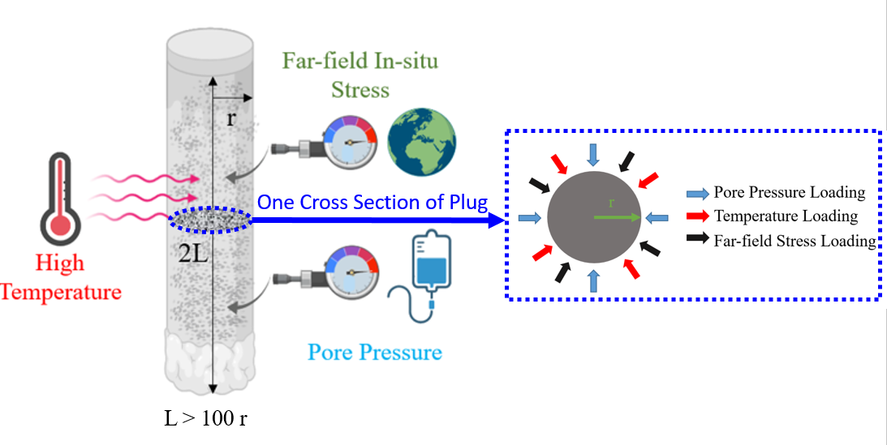

Figure 1. Left side: Sketch showing a primary plug in P&A and its boundary conditions; Right side: A zoom in sketch showing a cross-section of the plug in plane-strain conditions and its boundary conditions.

In line with the loading decomposition scheme proposed by Detournay et al. (1988) in the context of poroelasticity, the PTEOF model can be decomposed into three sub-loading cases to simplify the analysis. These are: 1) pore pressure loading (), 2) temperature loading (), and 3) isotropic far-field stress loading (), where the superscript i is denoting by the stress field that induced by the loading mode j which is the subscript. Thus, the boundary conditions at the outside surface of the primary cement plug for each of the loading modes can be written as follows (the subscript f denotes formation, subscript c denotes cement)

* Mode 1: ,, and ;
* Mode 2: ,, and ;
* Mode 3: ,, and .

Since the PTEOF model is linear, the principle of superposition will be used as final step to obtain the final solution. Note that, in general, there is a fourth mode of loading corresponding to deviatoric far field stress, which is neglected here but can be useful as a future investigation.

3.2 Solution to the fully coupled diffusion equations

The solution method starts with obtaining a general solution of the fully coupled diffusion equations (Eq. (9) and Eq. (10)). Note that the plane-strain assumption will lead to the conclusion that fluid and thermal transport will be only directed along the radial direction in the cylindrical coordinates system. Then, the first step is to eliminate  and  in the diffusion equations by substituting the constitute equation (Eq. (4)). This results in a new form of coupled diffusion equations

, (12)

. (13)

Next, by combining Eq. (3), Eq. (4) and Eq. (5), and taking the body force to zero, an extended form of the classical Navier equation is obtained as

. (14)

Drawing on the approach of Sarout et al. (2011), which modifies the theory of linear chemoporoelasticity into a convenient form, whereby the interpretations of the phenomenological parameters can be clarified, we can then use the irrotational field assumptions to simplify the process of solving the Navier equations. When displacement field is irrotational, i.e.  is the gradient of a scaler, one can integrate Eq. (14) to obtain

, (15)

where  and .

The functionresults from the integration and it therefore does not depend on the spatial coordinates (i.e. it is a spatially uniform function of time only). In fact, for many infinite or semi-infinite domain problems where conditions exist to require quantities decay to zero in the far field force to *f(t)* to be zero (Detournay et al., 1993). But, for the present finite domain equation,will not be zero but instead is a part of the solution. Next, by substituting Eq. (15) into Eq. (12) and Eq. (13), the volumetric strain  can be eliminated thus leaving the coupled diffusion equation

, (16)

where:

,

,

,

,

,

,

.

The diffusion equations in Eq. (16) are coupled in terms of  and , which can be transformed into uncoupled equations in terms of  and by using the eigen decomposition approach developed by Sarout et al. (2011). This methodology starts by obtaining two eigenvalues  and  of matrix. Then, the eigen decomposition theorem (Weisstein, 2002) allows us to define a transition matrix, which is composed of eigenvalues and eigenvectors of , and temperature and pore pressure are therefore given by

 , (17)

where

,

.

This transition leads directly to an uncoupled system of diffusion equations

, (18)

where . Then, by applying the Laplace transform to the eigenfunction

, (19)

where , it becomes an uncoupled system of ordinary differential equations (ODEs) in terms of variable , where  is function of the coordinators in cylindrical system ρ, and the Laplace parameter s and the ’s eigenvalue . These are

 (20)

These are zeroth-order modified Bessel equations, which have the general solution

, (21)

Here  , and  are unknowns that will be determined based on boundary conditions, andand are the zeroth-order modified Bessel functions of the first and second kind, respectively.

The next step is to invoke the symmetry conditions of the problem under consideration, which ensure that =0. Thus the pore pressure and temperature profile in the Laplace domain are

, (22)

. (23)

The radial stress under the plane-strain conditions (Eq. 11) consists volumetric strain () and radial strain (). Both of them can be obtained through the radial displacement , which is integrated by the Eq. (15). Thus, the radial stress can be expressed in Laplace domain as

, (24)

where  and .

Up to now, there are three unknowns , i=1,2, and  in the system. The first two unknowns  and come from the coefficient of the zeroth-order modified Bessel functions of the first kind and the third unknown  is coming from the spatially uniform function from Eq. (20). In the process of deriving the above expressions for the pore pressure, temperature, and radial stress (all in the Laplace domain), we can create three equations for these three unknowns

, （25）

where

,,

,

,

,

,

,

.

So when given a value of s, the three unknowns can be readily computed, thus the solution can be numerically inverted to the time domain using Stehfest’s method (Stehfest, 1970), which has been proved to be efficient in poroelastic problems, and its details are shown in Appendix B.

4. Behavior of the Model

This section will investigate different behaviors of the model and an example case is selected in order to have a further illustration. This example involves all three loading modes, specifically:

* Mode 1: the initial pore pressure of the cement plug is set up as zero and the virgin pore pressure of the formation is setup as Pa. Then a difference between the formation and cement plug is Pa;
* Mode 2: the initial temperature in cement is initially 453 K, and then a difference between the formation and cement is taken as ;
* Mode 3: the initial far-field isotropic stress is setup as Pa and is changed by Pa.

The modes of loading are inspired by similar cases described in the literature (e.g. Snee et al., 2018; Xu et al., 2015; Zoback et al., 2003), which also inspire the other parameters to be taken as



4.1 Pore pressure responses and thermal osmosis effect

The change of pore pressure () in response to different loadings is a key component in poromechanical analysis. It is therefore of interest to firstly plot the evolution of pore pressure under three different loading modes, given the boundary conditions that are defined in the last section, while the influence of the factors of interest on the pore pressure will be analyzed and discussed later.

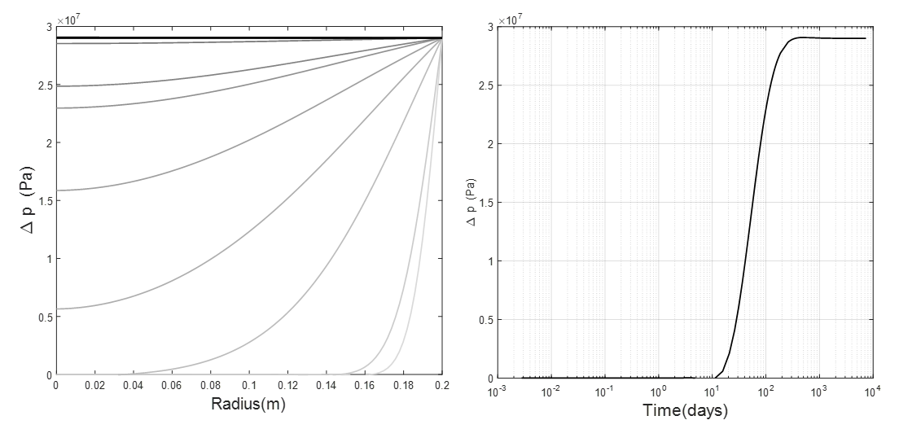

Figure 2. Left: pore pressure change () due to mode 1 loading, where the curves grade from gray to black as time increases; Right: evolution of pore pressure change () that induced by mode 1 at center of the cylinder () with time.

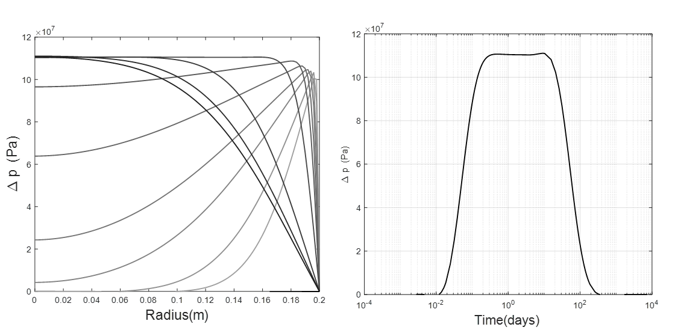

Figure 3. Left: pore pressure change () due to mode 2 loading, where the curves grade from gray to black as time increases; Right: evolution of pore pressure change () that induced by mode 2 at center of the cylinder () with time.

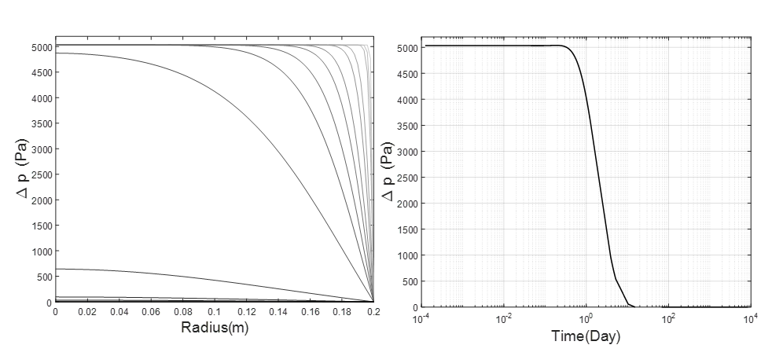

Figure 4. Left: pore pressure change () due to mode 3 loading, where the curves grade from gray to black as time increases; Right: evolution of pore pressure change () that induced by mode 3 at center of the cylinder () with time.

Figures 2a and 3a illustrate the pore pressure change () profile along the radius in response to mode 1 loading (pore pressure loading) and mode 2 loading (temperature loading), respectively. Under the mode 1 loading, the pore pressure evolution follows in the manner of a classical diffusion process. The pore pressure near the surface (r=0.2m) is instantly raised to the level of the pore pressure loading, and then the pore pressure is gradually diffused towards the center (r=0).

In contrast to gradual and smooth diffusion process from external pore pressure loading, the pore pressure induced by mode 2 temperature loading firstly peaks just inside the boundary. The pressure change at the boundary in this case is held at zero due to the boundary conditions. Once the initial pressure peak develops, it initially decreases to zero at the inner core, resulting in a pressure peak. This pore pressure peak results in fluid flux both toward the boundary and toward the center. However, because fluid diffusion is slow compared to thermal diffusion, the pressure does not appreciably dissipate. Instead, as the temperature front moves to the core, the pore pressure increases along with it. Eventually the pressure becomes nearly uniform through the central region, while it continues to have a gradient toward the boundary. Hence, the pressure is being alleviated by fluid diffusion across the outer boundary. But, again because of the slow fluid diffusion due to low hydraulic conductivity (in comparison to the thermal conductivity), for some time there persists only a small layer at the boundary where the pressure is able to drain. Eventually, long after the entire specimen is entirely heated, the entire pore pressure dissipates and returns to zero everywhere.

The time evolution of the pore pressure due to modes 1 and 2 loading is illustrated by the pressure at the center, shown in Figs. 2b and 3b. After pressure loading, the pore pressure in the center is shown for this example to begin increasing after about 1 month, reaching its peak, steady-state value after about 1 year. Hence, any pore pressure change that takes place over a time that is considerably smaller than this characteristic time of evolution can be approximated by the instantaneous change considered in this solution. The pore pressure due to thermal loading progresses somewhat more quickly, owing to the higher thermal diffusivity. After the thermal loading is induced, the pressure at the center begins to rise very soon thereafter, within less than 1 day. The induced pressure pulse in this example persists for a few months.

In contrast to the previous two modes, the pore pressure change () that is induced by mode 3 (isotropic far-field stress) is shown in Fig. 4a. Here the pore pressure immediately arrives at its highest value except in a small layer near the boundary where the pore pressure reduces to zero due to the boundary conditions. This initial pore pressure field gradually declines to zero everywhere due to fluid diffusion. The entire process for this example takes place over the course of about 1 month (Fig. 4b). It should be noted that the magnitude of the pore pressure induced by mode 3 is much smaller compared to the pore pressure induced by mode 1 and mode 2. Even at the highest level of pore pressure, which is right after the loading is applied, the ratio of mode 3 induced pore pressure over mode 1 and mode 2 induced pore pressure is around 0.01%-0.02%. This is also in line with the findings from the classical poroelastic model (Detournay et al. 1988).

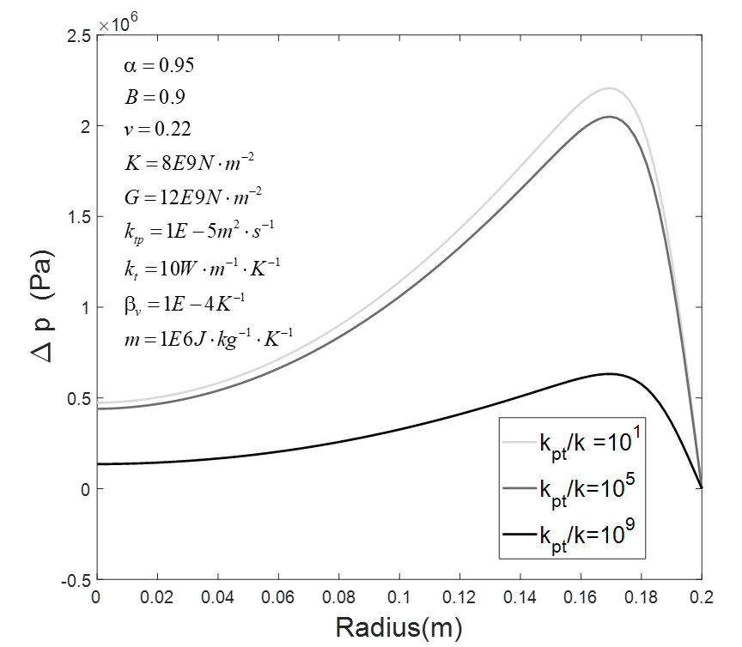

Figure 5. Various ratio of (thermo-osmosis’s influence) on the induced pore pressure (days)

4.2 Thermo-osmosis and thermo-filtration effects

So far, all results have been presented with a single combination of parameters governing thermos-osmosis and thermo-filtration. To examine these effects, we will present the internal pressure profile at *t*=10 days after thermal (mode 2) loading. Three different ratios (1, 105, 109) of  are selected to show the different developments of the temperature induced pore pressure (Fig. 5), noting that =1 corresponds to the case presented in Fig. 4. All three cases show a peak pore pressure near the surface region; however, the magnitude of the peak induced pore pressure has considerable reduction when the thermo-osmotic coefficient is significantly larger than the hydraulic conductivity (i.e., =109). While it is not clear if this ratio is realistic (it might be, but there has been little study), it is clear that thermos-osmosis does have potential to contribute a reduction in the induced pore pressure from temperature loading.

The role of thermo-filtration is most apparent by observing the temperature profiles resulting from the mode 2 (temperature) loading. A base case is shown in Figure 6. As the time proceeds, temperature is increasing monotonically from surface towards the inner core of the plug, and finally arrives at equilibrium, which is the equilibrium of the boundary conditions at the later time. Three different ratios of thermal conductivity over the thermal filtration coefficients are selected to show the impact of the thermal filtration effect on the temperature profile, that is changed by the pore pressure gradient. As shown in Figure 7, among the three selected ratios, the maximum temperature difference induced by the pore pressure gradient is within 1 degree Kelvin. Furthermore, when the thermal conductivity is significantly larger than the thermal filtration coefficient (=108), the induced temperature differences are negligible under the current model settings and inputs.



Figure 6. The development of temperature change () under the loading mode 2, where the curves grade from gray to black as time increases

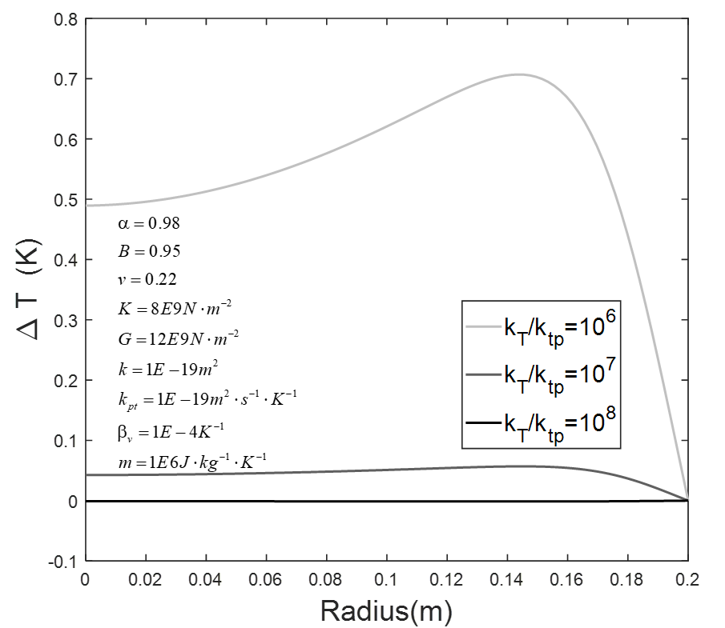

Figure 7. Various ratio of (thermal filtration’s influence) on the temperature change () profile

4.3 Effective Stress

There is a vast literature pointing to the impact of the so-called effective stress on behavior of porous media, where effective stress is defined as the difference between the total stress and the pore pressure (cite – perhaps Terzaghi and Biot). Its significance lies in that it quantifies the total stress carried by the solid skeleton. Hence, when it becomes tensile, it indicates that the skeleton is subjected to tension. In materials like cement, rock, and soil, the tensile strength is low and so generation of tension indicates risk of tensile failure. Here, the effective radial stress  is obtained as the superposition of the effective stress  from three loading modes as

 (24)

The result is plotted in Fig. 8. Recall that tension is positive. It is observed that after the cement is placed under the pore pressure, temperature, and stress loading, the induced pore pressure will increase and will therefore reduce the radial effective stress near the boundary and can create a region where effective stress is tensile. However, outside of this region, at early times the rest of the material will still be subjected to compressive effective stresses. However, because the pore pressure diffusion process is very slow compared to thermal diffusion, the pore pressure continues to increase through to the center and eventually a tensile region will be created throughout the central region. Finally, at a later time when induced pore pressure is fully dissipated, the radial effective stress will return to be compressive again. This demonstration of the whole diffusion process indicates that cementing under the HTHP has potential to induce a high value of pore pressure, which will lower the effective stress and can even generate a tensile region. This coupled behavior can therefore lead to cracking of the cement, jeopardizing the integrity of the cementing system with the potential to trigger unwanted consequences.

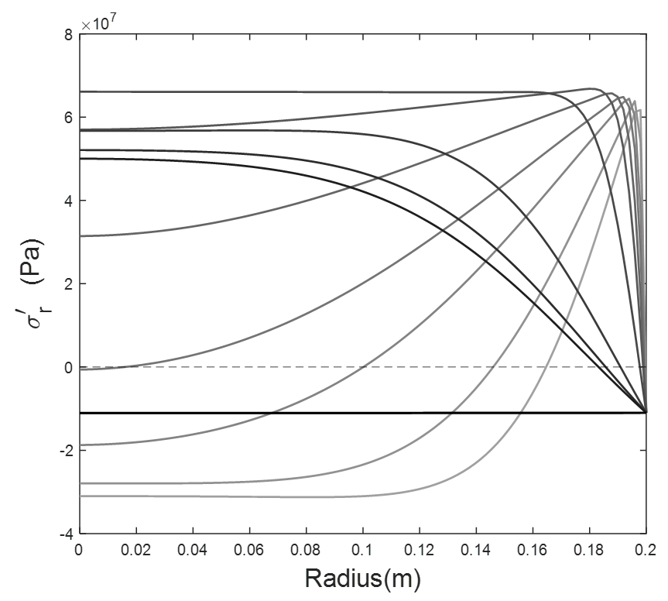

Figure 8. Effective radial stress of cement, with tension positive, where the curves grade from gray to black as time increases (boundary conditions and input values of each parameter are stated at the beginning of this section).

5. Pairwise Bivariate Analysis and Dimensional Analysis

The system behaviors discussed so far depend on the different values of input parameters and the mutual interactions of the physical processes they determine. If some of these parameters take on different values, the results can be much different. Thus, it is important to investigate the potential prevalence of the high pore pressure generation and its associated generation of tensile effective stress. The analysis starts with assigning values at random to each parameter within a certain range, as summarized in Table 2 in Appendix A. Once these variables have been given values according to this Monte Carlo approach, they are substituted into the semi-analytical solution and a new solution is thus computed. For each solution, the most tensile effective radial stress at any location and any time is extracted from the data and then used to classify the case as “tensile” or “compressive”. The details of the above-mentioned procedures are summarized in the flowchart in Figure 9.

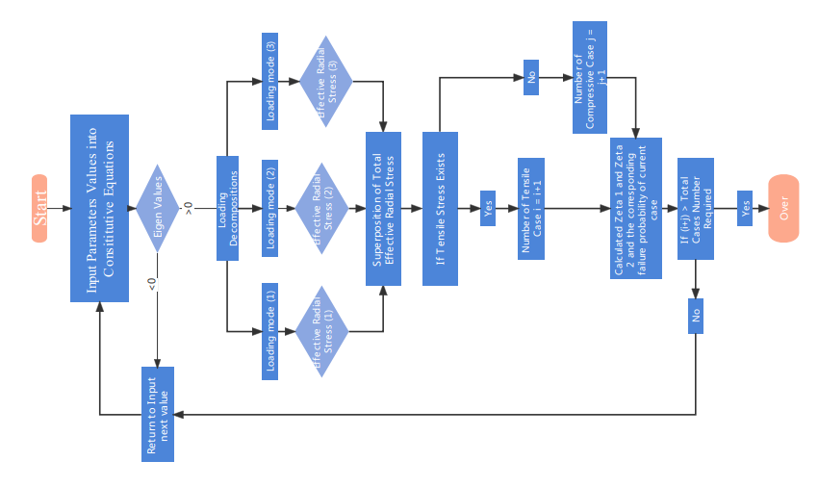

Figure 9. The Algorithm that is used to construct the fully parametric studies

5.1 Pairwise Bivariate Analysis for Each Variable

Following the procedures the flowchart described in Figure 9, a total of 3000 cases are calculated and then categorized into two groups: tensile (2127 cases) and compressive (913 cases). Next, the relationship between each variable and the outcome of “tensile” is examined by the pairwise bivariate distributions that are shown in Appendix C. The non-diagonal elements are scatter plots which display the correlation between two variables and give insight on the distribution features of these variables. The matrix of the results is symmetric about its diagonal. The diagonal elements are univariate distribution plots which are drawn to show the probability density function of each variable. It can be found that in the events of a tensile case, the specific heat and permeability are more concentrated at their lower range, and the thermal conductivity and the thermal expansion coefficient differences are more concentrated at their higher range, whereas the rest of the parameters are almost evenly distributed along their whole range. This indicates a general trend that, within the framework of PTEOF, at higher values of  and lower values of  and  will increase the propensity for generating tensile radial effective stress increases.

The impact of permeability on tendency to generate tension is a point that bears further discussion. One common cement design principle is that lower hydraulic conductivity is synonymous with a better cement barrier. This cement designing philosophy is possibly effective under many working conditions (i.e., ambient temperature and pressure) that cement is originally built for. However, when the cement is placed under the HTHP conditions, and poromechanics are taken into considerations, our results show that the lower permeability will actually increase the probability of the cement experiencing tensile effect stress, which can be detrimental to the integrity of the cementing system. This is mainly due to the fact that under the framework of porous media, the lower permeability will greatly slow down the pore fluid diffusion process when the pore pressure is rapidly built up within the cement due to the HTHP boundary conditions. Hence, the pursuit of low permeability regardless of the intrinsic porous properties of the cement itself and without guidance from poromechanical models could instead increase likelihood of degradation of the cement and hence reduce its effectiveness at providing mechanical support and zonal isolation. In other words, there is a negative aspect to having permeability that is too low, which we will henceforth call a “permeability penalty”. To avoid the permeability penalty for cementing design under HTHP, perhaps the most favorable solution is to keep the permeability at certain ranges which can achieve the sealing function, but at the same time, allowing the diffusion of pore pressure that is built up by the HTHP conditions and therefore not cause unnecessary damage induced by the excess pore pressure. This permeability-forgiveness design is actually very popular in pavement design of permeable porous systems (PPS) (Scholz et al., 2007) where one or two special drainage layers with relative higher permeability are designed in a more effective and efficient way that reduces the runoff rates in the storm while providing a hard surface for the traffic flow. The PPS design has been successfully turned into wide variety of residential, commercial, and industrial applications in the last two decades (Drake et al., 2013). Furthermore, finding a suitable permeability window should in principle be possible for wellbore cementing owing to the vast difference between the length scale associated with drainage of pore pressure to a radial boundary and the length scale associated with fluid diffusion through the length of the barrier. A permeability that is high enough to allow the former while preventing the latter should be attainable.

It also worth mentioning that the specific heat capacity has received little attention in previous research of HTHP cementing design. However, based on our results, it does play a very important role, similar to the role of thermal conductivity, as a large specific heat capacity will slow down the heat transfer process and hence reduce the tendency to generate the thermally-induced pore pressure. This will give the pore-pressure more time to dissipate compared to the rate of its build-up. This observation suggests a new direction for creating cement with high specific heat capacity and low thermal conductivity which would comprise suitable design for HTHP conditions.

5.2 Parameter Groups Governing Effective Stress Evolution

Although the pairwise bivariate distributions shown in Appendix C gives a full picture of how each parameter will individually influence the system behavior, the mutual interactions of different properties and their group effect cannot be analyzed from it. To solve this problem, classical scaling and dimensional is utilized. Usually these methods are used to reduce a complex physical problem to a simpler version (at least in terms of the number of governing parameters) prior to obtaining a quantitative answer while also grasping the effects of various physical phenomena at the same time. With that said, it is not clear from the governing equations alone which grouping(s) of parameters have the most important effects on the propensity to generate tensile effect stress. However, by dimensional analysis and guided by intuition, one can propose two dimensionless parameters as

  (25)

The first dimensionless group,, consists of the Biot coefficient , Skempton coefficient , thermal expansion coefficient of fluid  and solid  , as well as thermal diffusivity  and fluid diffusivity , where the last two terms are obtained from the diagonal elements of the coefficient matrix in Eq. 15. This proposed mainly contains the hydro-thermal properties of the porous media. It is thus named the Hydro-Thermal Non-Dimensional parameter (HTND). The second proposed parameter,, consists of three mechanical related components: Shear Modulus, Bulk Modulus, and Poisson’s ratio. Thus, it is named the Mechanical Non-Dimensional parameter (MND).

Given the newly proposed parameters, a new plot can by generated to show the tensile and compressive spatial distribution cases based on( HTND) and(MND). In Figure 10 (a), the same 3000 cases are replotted where the red dot represents the tensile case and the green dot represents the compressive case. It can be clearly seen that the spatial distributions of the tensile and compressive cases in thevs. plot heavily depend on the whereas both tensile and compressive cases are almost evenly distributed along theaxis. This indicates that the influence of on the system dominates when compared with . Futhermore, in Fig. 10(b) where is equally divided into 200 intervals, the probability of generating the tensile cases in each of these intervals is calculated. It is shown that in the area where theare smaller than 0.07 is fully occupied by compressive cases; not a single tensile case exists in this region. It is thus called the safe zone, which means no tensile failure would be expected to occur within this range under the framework of the PTEOF model (and for the particular boundary and initial conditions considered in this example). When  increases from 0.07 to 0.23, the probablity of generating tensile cases gradually increases up to 100%. Both tensile and compressive cases could happen in this region, but with a higher value of , the possibility of generating a tensile case will be higher. This area is thus called the transition zone. When is greater than 0.24, no compressive case is exists within this range and it is fully occupied by tensile cases, which means the probality of generting a tensile cases is 100%. It is thus named the damage zone which means when designing the cement under the HTHP conditions, if the resulting is landing greater 1, tensile damage will certainly occur in the cement.

Drawing on the conclusions above, it can be clearly seen that the Bulk Modulus, Shear Modulus and Poisson’s ratio, which are considered as three of the most important mechanical properties, have very limited contribution to the system behavior when in terms of its propensity to generate poromechanical tensile effective stress. ~~This actually challenges the current HTHP cementing design principles which always prioritize making the cement stronger and more ductile, hoping that the cementing system will thus have more resilience and less possibility of failure~~. ~~However, based on our results, this actually may not help to maintain the cement integrity under the HTHP conditions. That is to say, when designing the cement under the HTHP conditions, rather than give the highest priority to these mechanical properties,~~ So, this work suggests that from at least this one perspective, more attention should be put into the components that keep the value of below 0.07, as to avoid potential for tensile damage. For example, as shown in Fig.11, the Peak 1 is recalled from the Fig. 3b, giving a case for which equals to 1.26. This case is firmly in the “damage zone”. However, if the permeability of the material is reduced by two orders of magnitude, the induced pressure is much lower, shown here as Peak 2. Still, the value of  and Fig. 10b suggests a probability of 95% to generate tensile effective stress. If the specific heat of Peak 2 is further reduced by two orders of magnitude, the induced pore pressure will have an even more considerable reduction (Peak 3). The corresponding = 0.03, which is indicated in Fig. 10 to be in the “safe zone” with negligible probability of generating tensile effective stress.

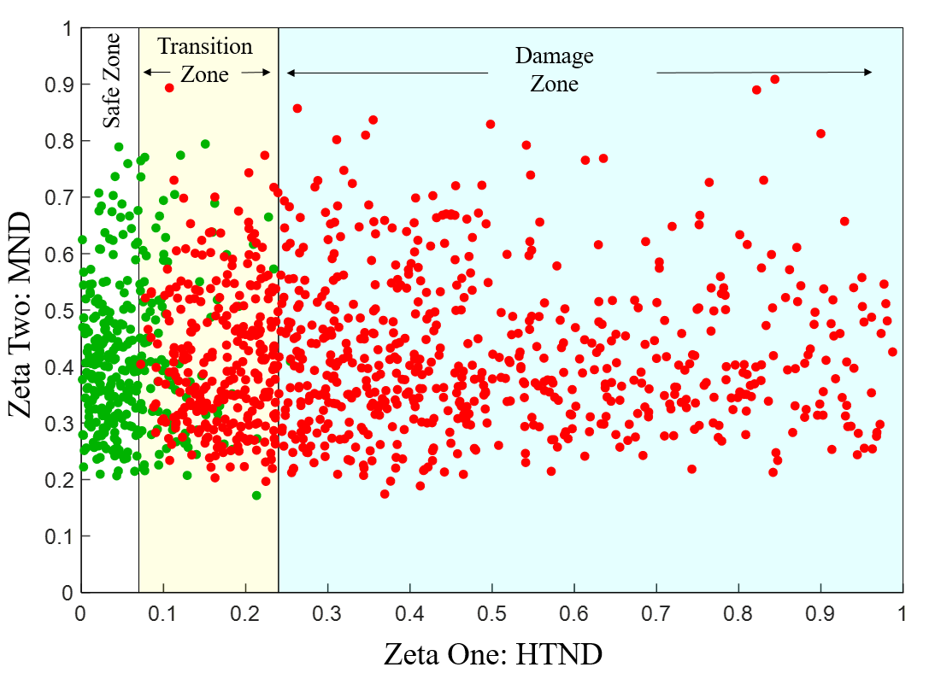

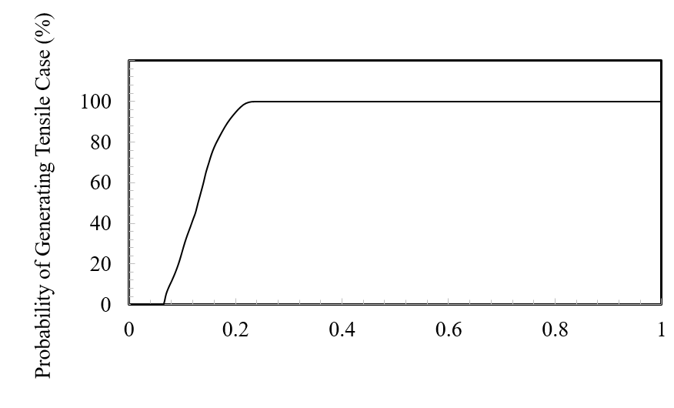

Figure 10. a) (HTND) and(MND) plot with tensile cases (red color) and compressive cases (green color). Note the range of Zeta One can be larger than 1 based on the ranges of the selected parameters. However, the probability of generating the tensile case is always 100% when Zeta One is larger than 0.24. b) The probability plot of generating tensile cases on different  (HTND) values.

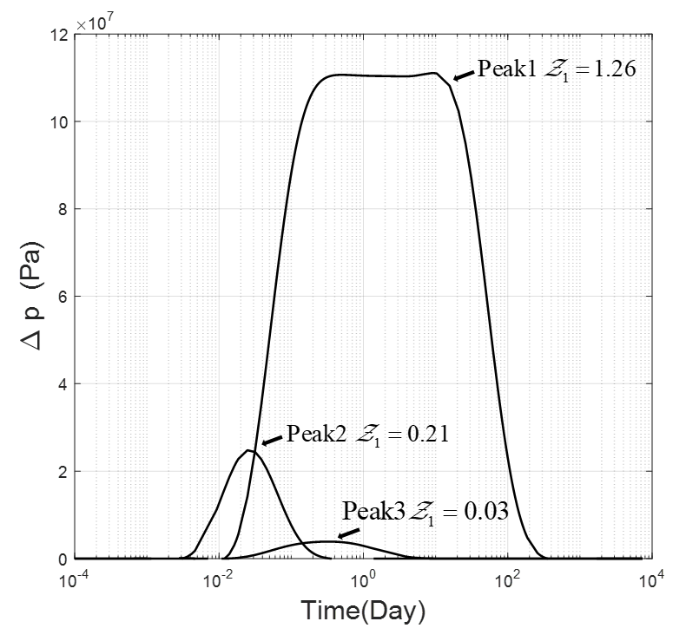

Figure 11. The influence of Zeta 1 on the Mode 2 induced pore pressure. Peak 1 is recalled from Fig. 3 Right; The permeability of Peak 2 is three orders of magnitude smaller than Peak 1, the rest of selected parameters remain the same as Peak 1; The specific heat of Peak 3 is two orders of magnitude smaller than Peak 2, the rest of selected parameters remains the same as Peak 2.

6. Conclusions

Using the primary cementing in P&A as an example, the fully coupled porothermoelastic-osmosis-filtration (PTEOF) model is presented here. It has been demonstrated that under HTHP conditions, the induced pore pressure in low permeability material such as cement can be so large that it can generate tensile effective stresses. This phenomenon will, in general, increase the probability of cement failure. By the pairwise bivariate analysis, the properties that are important for the HTHP cementing are parsed out. Based on these results, two new concepts are proposed in which: 1) permeability targets a desired range that is large enough to facilitate timely dissipation of pore pressure due to radial fluid flow while still giving the necessary zonal isolation by preventing axial flow through the length of the plug, and 2) seeking methods to substantially increase the specific heat of the cement. Furthermore, by scaling analysis and Monte Carlo simulation, three zones (safe, transition, and damage) with clear boundary values are shown in the (HTDN) and (MDT) plot. Of these, Z1 is by far the most influential, showing that cement design with higher … and lower … is expected to reduce the likelihood of pore-pressure induced failure as the cement experiences temperature changes during its service life.

A practical implication is that thermal properties, such as thermal conductivity, specific heat capacity, thermal expansion coefficient ratio, deserve more attention in cement design for HTHP conditions. The potential impact of increasing the specific heat capacity is substantial, especially because it allows mitigation of pore pressure buildup without the need to deliberately increase the hydraulic diffusivity (which may not be desirable for other reasons).

These results show the need for mechanical modeling to guide design of cementing materials for HTHP conditions. Common cement improvement practices, such as including different additives into cement to enhance its mechanical properties, will not change the fact that cement is inevitably a porous media. While the new additive can change the pore space into various sizes as small as the nano-scale, without considering the underlying physical principles governing the mechanical behaviors within a poromechanical framework, modifications of properties with on objective in mind could inadvertently increase risk of failure due to another mechanism. On the other hand, guided by fully-coupled modelling, the future of cement design for HTHP conditions can be more effective by pursuing directions that may not be apparent without the use of a poromechanical model. . ~~sometimes will jeopardize the whole system instead. Our results indicate that when cementing under HTHP conditions, the mechanical properties, such as shear modulus and Poisson’s ratio, may not be the most important parameters to maintain the integrity of cement, and the low permeability will actually cause the tensile stress to damage the system. Thus, we are proposing a new cementing design principle of permeability forgiveness, which allows for some tolerance of permeability in order to avoid the permeability penalty.~~

Acknowledgments

This research is supported by the National Academy of Science and Mathematics Gulf Research Program (NASEM-GRP) grant # 10002358 and the Project Research Team Members: Mileva Radonjic from Oklahoma State University, Raissa Ferron group from University of Texas Austin, Ipsita Gupta group from Louisiana State University and Pierre Cerasi from SINTEF. Thanks go to Charles Hager (PITT) for the outstanding technical contributions. We are grateful for the support of our entire research group who make the Hydraulic Fracturing Lab here at University of Pittsburgh and finally the postdoc scholar and graduate students from NASEM GRP funded project: Cindy Cao (OSU), Mercy Achang (OSU), Cody, Massion (OSU), Vamsi Vissa (OSU), Tamitope Ajayi (LSU), Farzana Rahman (UTA) and especially Hope Asala, who is no longer with us due to a tragic accident.

Appendix A: Table 1. Notation

|  |  |  |
| --- | --- | --- |
| Symbol | Definition | Unit |
|  | Biot effective stress coefficient | --- |
|  | Drained thermoelastic effective stress coefficient | N⋅m-2⋅K-1 |
|  | Skempton pore pressure coefficient | --- |
|  | Coefficient of volumetric thermal expansion of solid | K-1 |
|  | Coefficient of volumetric thermal expansion of porosity | K-1 |
|  | Coefficient of volumetric thermal expansion of fluid | K-1 |
|  | Coefficient of volumetric thermal expansion for variation in fluid content | K-1 |
|  | Drained coefficient of volumetric thermal expansion of porous medium frame | K-1 |
|  | Specific heat of the porous medium at reference temperature | J⋅kg−1⋅K−1 |
|  | Fluid flux | m⋅s−1 |
|  | Heat flux | J⋅m−2⋅s−1 |
|  | Permeability | m2 |
|  | Thermal conductivity | W⋅K−1⋅m−1 |
|  | Mechano-caloric coefficient (Thermal filtration) | m2⋅s−1 |
|  | Thermo-osmosis coefficient | m2⋅s−1⋅K−1 |
|  | Poisson’s ratio | --- |
|  | Drained bulk modulus | N⋅m-2 |
|  | Shear modulus | N⋅m-2 |
|  | Thermal Diffusivity | m2/s |
|  | Fluid Diffusivity | m2/s |

Table 2. Lower boundary and upper boundary for Monte Carlo Sampling (the unit of each parameter is the same as the unit defined in Table 1)

|  |  |  |
| --- | --- | --- |
|  | Lower Boundary | Upper Boundary |
|  | 0.25 | 0.95 |
|  | 0.28 | 0.98 |
|  | 1E-5 | 1E-3 |
|  | 8E9 | 16E9 |
|  | 12E9 | 24E9 |
|  | 0.22 | 0.32 |
|  | 1E-21 | 1E-16 |
|  | 1E0 | 1E2 |
|  | 1E-6 | 1E-9 |
|  | 1E-22 | 1E-19 |
|  | 1E5 | 1E8 |

Appendix B: Details of Stehfest’s method

For a given function p with Laplace transform, Stehfest’s method can be expressed as, taking pore pressure for example:



Where the coefficient are given by



Appendix C:

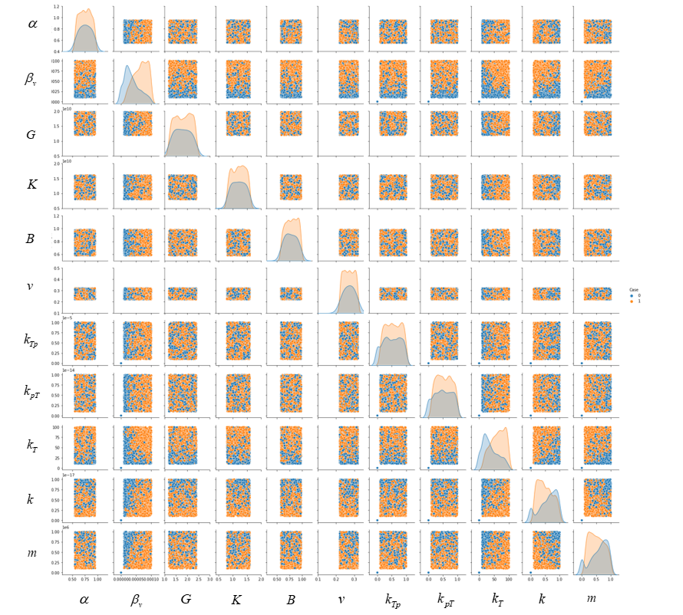

Pairwise bivariate distributions for eleven variables (each orange color dot represents a tensile case and each blue color dot represents a compressive case)

References

Ahmed, S., Salehi, S., & Ezeakacha, C. (2020). Review of gas migration and wellbore leakage in liner hanger dual barrier system: Challenges and implications for industry. *Journal of Natural Gas Science and Engineering, 78*, 103284.

Allahvirdizadeh, P. (2020). A review on geothermal wells: Well integrity issues. *Journal of cleaner production, 275*, 124009.

Banthia, N., & Mindess, S. (1989). Water permeability of cement paste. *Cement and concrete research, 19*(5), 727-736.

Bear, J., & Corapcioglu, M. (1981). A mathematical model for consolidation in a thermoelastic aquifer due to hot water injection or pumping. *Water Resources Research, 17*(3), 723-736.

Biot, M. A. (1941). General theory of three‐dimensional consolidation. *Journal of applied physics, 12*(2), 155-164.

Biot, M. A. (1977). Variational Lagrangian-thermodynamics of nonisothermal finite strain mechanics of porous solids and thermomolecular diffusion. *International Journal of Solids and Structures, 13*(6), 579-597.

Cai, W., Deng, J., Luo, M., Feng, Y., Li, J., & Liu, Q. (2022). Recent advances of cementing technologies for ultra-HTHP formations. *International Journal of Oil, Gas and Coal Technology, 29*(1), 27-51.

Carnahan, C. (1983). Thermodynamic coupling of heat and matter flows in near-field regions of nuclear waste repositories. *MRS Online Proceedings Library (OPL), 26*.

Chen, G., & Ewy, R. T. (2005). Thermoporoelastic effect on wellbore stability. *SpE Journal, 10*(02), 121-129.

Cheng, A. H.-D. (2016). *Poroelasticity* (Vol. 27): Springer.

DeBruijn, G., Skeates, C., Greenaway, R., Harrison, D., Parris, M., James, S., . . . Temple, L. (2008). High-pressure, high-temperature technologies. *Oilfield Review, 20*(3), 46-60.

Delaney, P. T. (1982). Rapid intrusion of magma into wet rock: Groundwater flow due to pore pressure increases. *Journal of Geophysical Research: Solid Earth, 87*(B9), 7739-7756.

Derski, W. (1979). Equations of linear thermoconsolidation. *Archives of Mech., 31*(3), 303-316.

Detournay, E., & Cheng, A.-D. (1988). Poroelastic response of a borehole in a non-hydrostatic stress field. *International Journal of Rock Mechanics and Mining Sciences & Geomechanics Abstracts, 25*(3), 171-182.

Detournay, E., & Cheng, A. H.-D. (1993). Fundamentals of poroelasticity. In *Analysis and design methods* (pp. 113-171): Elsevier.

Drake, J. A., Bradford, A., & Marsalek, J. (2013). Review of environmental performance of permeable pavement systems: state of the knowledge. *Water Quality Research Journal of Canada, 48*(3), 203-222.

Gao, J., Deng, J., Lan, K., Song, Z., Feng, Y., & Chang, L. (2017). A porothermoelastic solution for the inclined borehole in a transversely isotropic medium subjected to thermal osmosis and thermal filtration effects. *Geothermics, 67*, 114-134.

Ge, Z., Yao, X., Wang, X., Zhang, W., & Yang, T. (2018). Thermal performance and microstructure of oil well cement paste containing subsphaeroidal konilite flour in HTHP conditions. *Construction and Building Materials, 172*, 787-794.

Ghabezloo, S., & Sulem, J. (2010). Temperature induced pore fluid pressurization in geomaterials. *arXiv preprint arXiv:1011.6501*.

Ghassemi, A., & Diek, A. (2002). Porothermoelasticity for swelling shales. *Journal of Petroleum Science and Engineering, 34*(1-4), 123-135.

Ghassemi, A., Tao, Q., & Diek, A. (2009). Influence of coupled chemo-poro-thermoelastic processes on pore pressure and stress distributions around a wellbore in swelling shale. *Journal of Petroleum Science and Engineering, 67*(1-2), 57-64.

Gomar, M., Goodarznia, I., & Shadizadeh, S. R. (2014). Transient thermo-poroelastic finite element analysis of borehole breakouts. *International Journal of Rock Mechanics and Mining Sciences, 71*, 418-428.

Gonçalvès, J., & Trémosa, J. (2010). Estimating thermo-osmotic coefficients in clay-rocks: I. Theoretical insights. *Journal of colloid and interface science, 342*(1), 166-174.

Goto, S., & Roy, D. M. (1981). The effect of w/c ratio and curing temperature on the permeability of hardened cement paste. *Cement and concrete research, 11*(4), 575-579.

Gruber, S., & Plank, J. (2021). Challenges in Cementing Deep Offshore Wells. *Vietnam Symposium on Advances in Offshore Engineering*, 459-466. doi:<https://doi.org/10.1007/978-981-16-7735-9_5>

Hargis, C. W., Chen, I. A., Devenney, M., Fernandez, M. J., Gilliam, R. J., & Thatcher, R. P. (2021). Calcium Carbonate Cement: A Carbon Capture, Utilization, and Storage (CCUS) Technique. *Materials, 14*(11), 2709.

Katende, A., Lu, Y., Bunger, A., & Radonjic, M. (2020). Experimental quantification of the effect of oil based drilling fluid contamination on properties of wellbore cement. *Journal of Natural Gas Science and Engineering, 79*, 103328.

Khalifeh, M., & Saasen, A. (2020). *Introduction to permanent plug and abandonment of wells*: Springer Nature.

Khalili, N., Geiser, F., & Blight, G. (2004). Effective stress in unsaturated soils: Review with new evidence. *International journal of Geomechanics, 4*(2), 115-126.

Kiran, R., Teodoriu, C., Dadmohammadi, Y., Nygaard, R., Wood, D., Mokhtari, M., & Salehi, S. (2017). Identification and evaluation of well integrity and causes of failure of well integrity barriers (A review). *Journal of Natural Gas Science and Engineering, 45*, 511-526.

Koťátková, J., Zatloukal, J., Reiterman, P., & Kolář, K. (2017). Concrete and cement composites used for radioactive waste deposition. *Journal of environmental radioactivity, 178*, 147-155.

Krakowiak, K. J., Thomas, J. J., James, S., Abuhaikal, M., & Ulm, F.-J. (2018). Development of silica-enriched cement-based materials with improved aging resistance for application in high-temperature environments. *Cement and concrete research, 105*, 91-110.

Kurashige, M. (1989). A thermoelastic theory of fluid-filled porous materials. *International Journal of Solids and Structures, 25*(9), 1039-1052.

Massion, C., Radonjic, M., Lu, Y., Bunger, A., & Crandall, D. (2021). *Impact of Graphene and the Testing Conditions on the Wellbore Cement Mechanical and Microstructural Properties.* Paper presented at the 55th US Rock Mechanics/Geomechanics Symposium, Paper number: ARMA 21–2089 20-23, June, 2021, Houston, Texas.

Massion, C., Vissa, V. S., Lu, Y., Crandall, D., Bunger, A., & Radonjic, M. (2022). Geomimicry-Inspired Micro-Nano Concrete as Subsurface Hydraulic Barrier Materials: Learning from Shale Rocks as Best Geological Seals. In *REWAS 2022: Energy Technologies and CO2 Management (Volume II)* (pp. 129-138): Springer.

Meng, M., Frash, L. P., Carey, J. W., Li, W., Welch, N. J., & Zhang, W. (2021). Cement stress and microstructure evolution during curing in semi-rigid high-pressure environments. *Cement and concrete research, 149*, 106555.

Olson, J., Eustes, A., Fleckenstein, W., Eker, E., Baker, R., & Augustine, C. (2015). Completion Design Considerations for a Horizontal Enhanced Geothermal System. *GRC Transactions, 39*, 335-344.

Picandet, V., Rangeard, D., Perrot, A., & Lecompte, T. (2011). Permeability measurement of fresh cement paste. *Cement and concrete research, 41*(3), 330-338.

Qin, J., Pang, X., Cheng, G., Bu, Y., & Liu, H. (2021). Influences of different admixtures on the properties of oil well cement systems at HPHT conditions. *Cement and Concrete Composites, 123*, 104202.

Roshan, H., Andersen, M., & Acworth, R. (2015). Effect of solid–fluid thermal expansion on thermo-osmotic tests: an experimental and analytical study. *Journal of Petroleum Science and Engineering, 126*, 222-230.

Samarakoon, M., Ranjith, P., & Wanniarachchi, W. (2022). Properties of well cement following carbonated brine exposure under HTHP conditions: A comparative study of alkali-activated and class G cements. *Cement and Concrete Composites, 126*, 104342.

Sarout, J., & Detournay, E. (2011). Chemoporoelastic analysis and experimental validation of the pore pressure transmission test for reactive shales. *International Journal of Rock Mechanics and Mining Sciences, 48*(5), 759-772.

Scholz, M., & Grabowiecki, P. (2007). Review of permeable pavement systems. *Building and environment, 42*(11), 3830-3836.

Shapiro, A. (2003). Monte Carlo sampling methods. *Handbooks in operations research and management science, 10*, 353-425.

Skempton, A. (1984). Effective stress in soils, concrete and rocks. *Selected papers on soil mechanics, 1032*(3), 4-16.

Smith, D. W., & Booker, J. R. (1993). Green's functions for a fully coupled thermoporoelastic material. *International Journal for Numerical and Analytical Methods in Geomechanics, 17*(3), 139-163.

Snee, J.-E. L., & Zoback, M. D. (2018). State of stress in the Permian Basin, Texas and New Mexico: Implications for induced seismicity. *The Leading Edge, 37*(2), 127-134.

Song, Z., Liang, F., Lin, C., & Xiang, Y. (2019). Interaction of pore pressures in double-porosity medium: Fluid injection in borehole. *Computers and Geotechnics, 107*, 142-149.

Stehfest, H. (1970). Algorithm 368: Numerical inversion of Laplace transforms [D5]. *Communications of the ACM, 13*(1), 47-49.

Tao, Q., & Ghassemi, A. (2010). Poro-thermoelastic borehole stress analysis for determination of the in situ stress and rock strength. *Geothermics, 39*(3), 250-259.

Trémosa, J., Gonçalvès, J., Matray, J., & Violette, S. (2010). Estimating thermo-osmotic coefficients in clay-rocks: II. In situ experimental approach. *Journal of colloid and interface science, 342*(1), 175-184.

Valov, A., Golovin, S., Shcherbakov, V., & Kuznetsov, D. (2022). Thermoporoelastic model for the cement sheath failure in a cased and cemented wellbore. *Journal of Petroleum Science and Engineering, 210*, 109916.

Vrålstad, T., Saasen, A., Fjær, E., Øia, T., Ytrehus, J. D., & Khalifeh, M. (2019). Plug & abandonment of offshore wells: Ensuring long-term well integrity and cost-efficiency. *Journal of Petroleum Science and Engineering, 173*, 478-491.

Wang, H. F. (2017). *Theory of linear poroelasticity with applications to geomechanics and hydrogeology*: Princeton University Press.

Wang, Y., & Dusseault, M. B. (2003). A coupled conductive–convective thermo-poroelastic solution and implications for wellbore stability. *Journal of Petroleum Science and Engineering, 38*(3-4), 187-198.

Weisstein, E. W. (2002). Eigen decomposition. [*https://mathworld*](https://mathworld)*. wolfram. com/*.

Xu, S., & Zoback, M. D. (2015). *Analysis of stress variations with depth in the Permian Basin Spraberry/Dean/Wolfcamp Shale.* Paper presented at the 49th US Rock Mechanics/Geomechanics Symposium, Paper number: ARMA-2015-189, June 28, 2015, San Francisco, California.

Zhou, X., & Ghassemi, A. (2009). Finite element analysis of coupled chemo-poro-thermo-mechanical effects around a wellbore in swelling shale. *International Journal of Rock Mechanics and Mining Sciences, 46*(4), 769-778.

Zoback, M., Barton, C., Brudy, M., Castillo, D., Finkbeiner, T., Grollimund, B., . . . Wiprut, D. (2003). Determination of stress orientation and magnitude in deep wells. *International Journal of Rock Mechanics and Mining Sciences, 40*(7-8), 1049-1076.